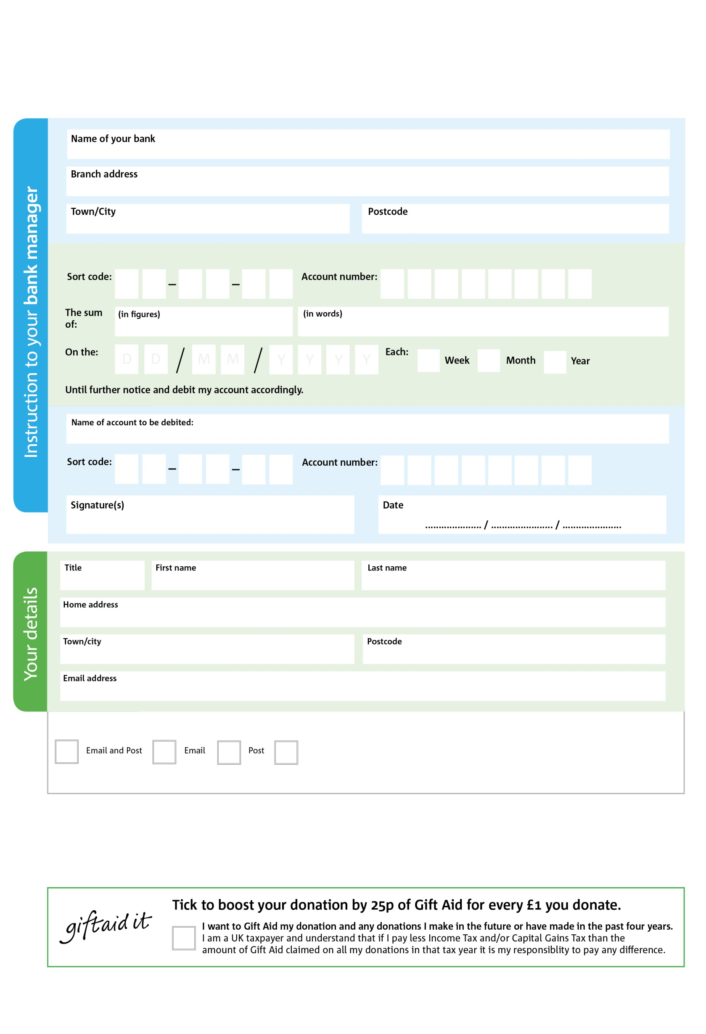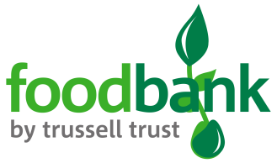

You can change your preferences any time by contacting us on 01579 550374 or emailing us at [coordinator@callingtonfoodbank.org.uk](mailto:coordinator@callingtonfoodbank.org.uk)

Reg. Charity No: 1192119 | Reg. in England & Wales

POSTAL ADDRESS: Callington Foodbank, 1 Launceston Road, Callington, PL17 7BS

3

V

4

V

6

V

2

V

2

V

2

V

7

V

6

V

**Please pass this form onto the foodbank, using the foodbank’s address at the bottom, who will save a copy for their records.   
They will then send it onto your named bank or building society.**

9

9

2

9

8

08

We would love to keep you up to date with information about Callington Foodbank. Please tick your preference:

I do not wish to receive future communications from Callington Foodbank

Please pay Callington Foodbank,

**Data protection**

Callington *Foodbank is committed to protecting your privacy and will process your personal data in accordance with current Data Protection legislation.* Callington *Foodbank collects information to keep in touch with you and supply you with information relating to our work. To unsubscribe from our newsletter, send a message to the email address above with the word unsubscribe in the subject line. A full data privacy statement for financial donors is available from the foodbank on request.’*

**Standing Order Mandate**

**callington.foodbank.org.uk**

You can change your preferences any time by contacting us on XXXXXXXXXXX or emailing us at XXXX@XXXXXXXXXX.foodbank.org.uk

I do not wish to receive future communications from XXXXXX Foodbank